Evaluating the alternatives of banking project strategies using the decision theory Methods

Prof.Dr. Muiead A. K. Al- Fadhel ¹ , Mayada Hayawi²
Al-Furat Al-Awssat Technical University / Technical College of Mangmnent ,Kufa,Iraq
Contact: lover.young99@yahoo.com

ABSTRACT: The private commercial banks should adopt different future strategies in the selection and identification of projects that should be adopted within the activities of investment or operating in the framework of various banking operations, that is to ensure the dominance of the management of the bank on market shares required of customers as well as to maintain competitive advantage on an ongoing basis . This is the essence of the problem. Ensuring that this requires the adoption of scientific methods in the decision-making process, including the methods of decision theory, as these methods would work to rationalize decisions by evaluating the alternatives available from banking projects, The aim of this study is to demonstrate the importance of using scientific methods, especially the theory of decision in the environment of uncertainties or the potential environment to evaluate the alternatives available in the banking project strategies. The Gulf Commercial Bank was adopted as a sample for this study. Can evaluate the strategies available for optimal selection, which will maximize its revenues. The researchers recommended at the end of the research to adopt the methods of decision theory (EVPI, EMV) and Baysen Theory to achieve this.

Keywords Decision Theory Methods , Bayes Theory, Project strategies

- INTRODUCTION
There is a clear perception among decision-makers in profit-making business organizations, including private commercial banks, that they must adopt different future strategies in the selection and identification of projects to be adopted within investment or operational activities within the framework of the various banking operations. Ensuring the dominance of the Bank's management over the required market share of the customers, as well as maintaining competitive advantage continuously. Ensuring that this requires relying on scientific methods in the decision-making process, including the methods of decision theory, as these methods will work to rationalize decisions by evaluating the alternatives available from banking projects. This study is located in four chapters, the first chapter devoted to the scientific methodology and previous studies. Chapter II is devoted to the intellectual framework of the study. The practical aspect was presented in Chapter 3 of the study. The conclusions and recommendations were presented in Chapter 4. The group of Arab and foreign scientific references was presented at the end of the study.

- Scientific methodology and literature Review
  - Scientific methodology
    - Research problem
The problem of the study is based on a fundamental question regarding the possibility of using the decision theory methods in evaluating the alternatives of the banking project strategies. The main objective is to maximize the expected future revenues of the bank sample of the study and take into consideration here the potential indicators that may affect the decisions of the bank .
    - Study Hypotheses
Our study was based on the following hypotheses:
1-The sample bank can conduct an evaluation of banking project strategies by adopting a package of decision theory methods
2 - The bank sample study can maximize its revenue by choosing the best strategy among the strategies available.
3- The bank's management may adopt the following studies and scientific researches in the context of the economic feasibility study to rationalize the evaluation process for the available banking projects.
4. Subsequent possibilities derived from subsequent studies and scientific research, which are adopted in the light of environmental influences, can serve to rationalize banking decisions.
    - Research Objective
Our study aims to achieve the following:
- the use of decision theory methods in the environment of uncertainty or the environment is likely to evaluate the alternatives available from the strategies of banking projects.
- identify alternatives to project strategies that can maximize the future revenues of the bank sample study.
- Support the approach or idea of conducting research and studies on the basis of past and subsequent positions of variables affecting investment decisions or operational.

    - Reserch importance
Our current study derives its importance from the following:
1 - Highlight the techniques related to the methods of decision theory and its possible use in the evaluation of alternatives to different strategies of business organizations, including banks, relating to future investment trends.
2 - Identify how to determine and diagnose opportunities and alternatives to investment and enable the management of the bank to stand up to it.
3-The Bank's management supported the sample of the study in the preparation of future strategies for future hedging in the uncertain environment of Iraq and the high risk indicators.

    - Resrch Model
Our current study model can be expressed in figure (1):
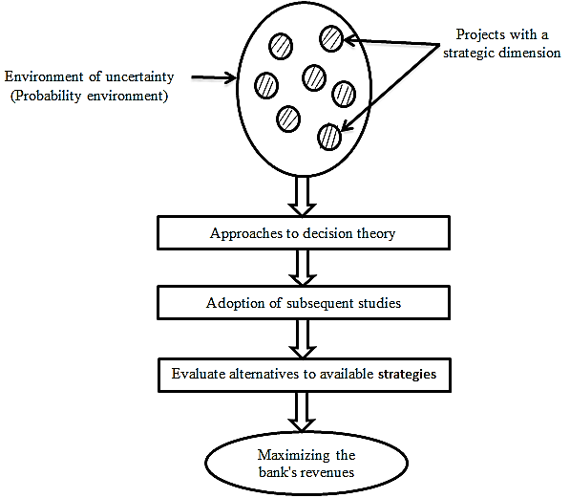
Figure (1): Building a study model

    - Society and sample of the study

The current study community is the private banks in general. The sample of the study is related to the Gulf Commercial Bank (the general center) with the study of all related branches in the different governorates (focusing on Najaf branch)
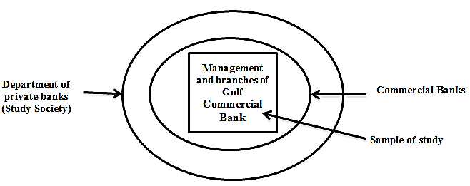
Figure (2) : Study sample site within the study population

  - literature Review
The following studies were selected:
- The study of (Smacka Ali Mahmoud 2016) "systems support marketing decisions and promotional mix and their role in rationalizing consumer behavior - a comparative study of Iraqi expenses," where he pointed to the importance of the importance of Iraqi banks to focus on rationalizing consumer behavior towards determining the required banking services that pass for the sample study Will serve as future banking projects and strategies, based on DSS methods. The researcher came out with a set of conclusions and recommendations that support the current trends of banks towards the adoption of scientific methods in decision-making.
- Al-Janabi Nasser Ramah, "Strategies of marketing mix and its role in determining the behavior of the Iraqi consumer towards local products." The researcher extensively discussed the importance of promotional mix strategies in the current Iraqi environment while taking into account the external and internal influences (of the probabilistic nature) Iraqi consumer towards local products of goods and services
- The study by Grankvist et al. (2004) "Promotion stratigies for Banking services-case study of Nordea in Estonia" The objective of the study is to clarify the strategies of promotion adopted by international banks through the adoption of promotional tools in the process of personal selling and advertising, to establish trade relations with different segments of customers according to the wide change in the tastes of customers and preferences, taking into account the subject of reducing costs and the adoption of economic measures.
- The study by (Kumar & Raju. 2013) " The Role of Advertising in consumer The Role of Advertising in Consumer Decision Making (Trad Bank as case study)" The two researchers dealt with the importance of advertising and pre-recognition of the wishes of the customer on the one hand, as well as the importance of the role of the bank in evaluating the alternatives of banking activities offered for marketing in order to choose the best ones that achieve the highest revenue and thus the possibility of dominance and control of the largest market share possible customers in the market while preserving the The competitive advantage of the said bank.

- The ideological framework of the study

  - The concept of decision theory and methods adopted
Decision Theory is one of the quantitative methods that fall within the quantitative approach to business management [1]. And are used for the purpose of rationalizing administrative decisions in various business organizations according to various quantitative and probabilistic calculations, and related to this theory a number of methods can be clarified as below:
- Games Theory
- Utility Theory
- Baysen Theory
- Decision Making Theory
This package of methods can be used separately or used in a single package, depending on the nature of the problem. The potential element is included in some cases of these methods, and the decision environment is divided into a possibility or uncertainty when it comes to investment decision-making.
  - Types of investment decision-making environment
Experts in decision-making or decision theory know three basic types of decision-making environment:
First: Decision Making with certainty
This is the ideal situation where the decision maker is sure of the nature of the external and internal influences that the bank is doing.
Second: Decision Making with Un certainty
Since the decision-maker in this case is not aware of the nature of external and internal influences and also does not know the proportions of the verification of future phenomena and nature. In this case, the decision maker uses a number of criteria known as rationalizing the administrative decision, such as:
- Max: Max Criteria
- Max: min Criteria
- Standard Reyrct Criteria
- Standard Laplace Criteria
- Standard Iterwitz Criteria
In this case, three types of decision makers are distinguished, as shown in Figure (3):
1. the Avoider decision maker (Avoider Risk)
2 - the normal decision maker Normal Risk
3. the Risk decision maker (Risk seker)

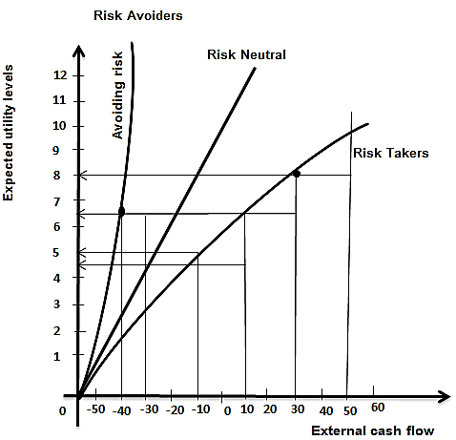
Figure (3) Tybes of Decision makers

Third : Decision Making Under Risk
In this case, the following criteria are used:
1) Expected Monetary Value (EMV)
The application of such a standard in practice to the management of investment in particular and the management of business in general requires the availability of the following:
A-There are a number of alternatives used by the decision-maker to achieve the desired goal (cases of nature)
B- the existence of multiple nature cases resulting in the existence of more than one return for each alternative.
C- that each of the states of nature can be achieved with different probability rates that are similar
D. The range of probability of the state of nature is equal to 1 ie: P1+P2+….Pn=1
The basic mathematical relationship on which the best alternative is based is as follows:
$$EMV= \sum_{i=1}^{n}{xi P\left(xi\right)} (1)$$
The mathematical relationship can be reopened as follows:
EMV=X1P(X1)+X2P(X2)+….+XnP(Xn) (2)
whereas:
i = number of variables i = 1,2, ... n
Xi = a random variable that expresses the state of nature of type (i)
P(xi) = Probability of random variable or state of nature
It should be noted here that the mathematical formula that expresses the structure and composition of the matrix of variables for nature states is as shown in Table (1)
The number of alternatives to available decisions is (S1,S2,….Sm)
Table (1):Matrix of variables for natural situations
Pn | P2 | P1 | S
X1n | X12 | X11 | S1
X2n | X22 | X12 | S2
... | ... | ... | …
... | ... | ... | ...
... | ... | ... | ...
Xmm | Xm2 | Xm1 | Sm

2) Expected Value of Perfect Information (EVPI)
The decision maker always tries to search for full information about the nature of the situation to reduce the risk. In this case, the decision maker is required to take advantage of the information and determine its value for the alternative to be studied and calculate the expected benefits of this information compared to the cost to be paid. Therefore, the decision-maker first looks at the expected value of the decision in case of full information (D), which is calculated according to the mathematical relationship:

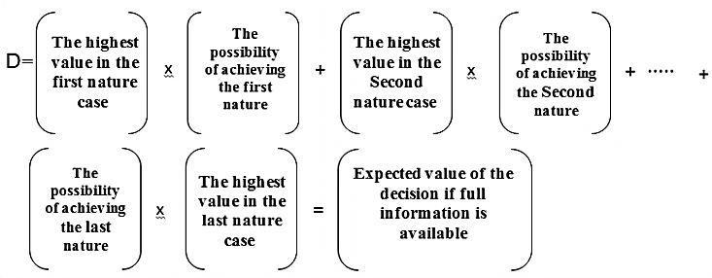
whereas:
D:Expected value of decision if full information is available
The value of the complete information contained in the knowledge acquired by the decision maker includes the difference between the expected value of the decision with full information and the expected value before full information is available (Max.EMV). That is, the value of the full information in the case of revenue is as follows:
$$EVPI=D-Max.EMV (3)$$
Where as:
EVPI: Current expected value criterion for complete information
EMV: Expected Financial Value Standard
3) Lost Opportunity Opportunity Standard: Expected Opportunity Loss (E0L)
In practice, the decision maker seeks to maximize the expected financial value (EMV) of any process, by minimizing or minimizing the lost opportunity value and by relying on a mathematical method of its components to construct and design the so-called regret matrix, (Taghavifard et al., 2009, p10-11). The lost opportunity is calculated by the following steps (Taghavifard et al., 2009, p10-11)
- Identifying and regulating remorse based on the development of data that treats each state of nature as a column in that matrix, and subtracting all the values ​​in that column from the largest value present in them.
- The value of EOL is calculated by multiplying the values ​​obtained from the regret matrix above in the probability of achieving each of the states of nature, and then collecting the results in all the columns of the matrix.
- the selection of the state of nature of lower value (EOL). It should be noted that the fundamental mathematical relationship on which EOL is calculated is as follows (Rokendro, 2012, p107):
$EOL\left(j\right)=\sum_{i=1}^{N}{Lijpi}$ (4)
whereas:
EOL(j) = the lost opportunity criterion for selected decision alternatives.
Lij = The lost opportunity resulting when the nature state of type (i) occurs.
Pi = probability of state of nature of type (i).
N = number of states of nature.
Note that the state of nature with the lowest EOL value is selected as the best alternative on which to base the decision.
- Practical side of the study
  - About Gulf Business Bank
Gulf Commercial Bank is a private shareholding company with paid up capital of 300 billion Iraqi Dinars. Paid up Capital I.D.300 Billion
The main location of the company is located in the Gulf region. It opened in Baghdad a main branch after 2003, and has opened several branches in the Iraqi provinces, including the province of Najaf, where he had two branches, and in 2006 merged into one branch. The bank conducts all banking operations. As a private business organization, the main motive of these banking operations is to achieve maximum returns and profits. Therefore, the Bank, through its various management structures, looks for opportunities and future alternatives (risk selcer) that achieve the highest financial benefits and profits. On this basis, and through the field visit to the branch of the bank mentioned in the province of Najaf, was briefed on the types of future strategies that the bank is looking at in order to raise the banking returns to the highest possible level.
  - Alternatives to available strategies (operational and investment)
Through the analysis and the reality of the case of the bank sample of the study, different types of strategies (future projects) have been reviewed, which the bank's management wishes to adopt to face different types of nature situations and estimated probability ratios based on accumulation of knowledge and experience. The objective nature of the target is, as mentioned above, the achievement of the appropriate revenue, which is different levels of revenue, and the probability of achieving it has been estimated and its levels as follows:
- The probability of achieving a very high income can be 20%
- The probability of achieving high income can be 30%
- The probability of achieving an average income can be 15%
- The probability of achieving a weak income can be 35%
In contrast to these four levels of income earning potential, the management of Gulf Bank can adopt the following operational strategies:
- Use of Visa Card cards in the process of withdrawing revenues in Iraqi currency and in dollars (Strategy n0.1).
- Using the Q-card system to pay the salaries of retired customers (Strategy n0.2).
- Providing loans for small projects up to JD (15) million with a lease contract (Strategy n0.3).
- Providing housing loans up to 50 million with a property under construction (Strategy n0.4).
- Opening savings accounts in local currency and hard currency with high interest rates (Strategy n0.5).
- Adoption of the ATM at the bank and in the commercial sites (malls, tourist sites, etc.) (Strategy n0.6).
- Providing consumer loans to buy a car or to support a marriage project and so on (Strategy n0.7).
- Opening documentary credits and selling hard currency at competitive prices to import goods and commodities (Strategy n0.8).

On the basis of the above strategies against the different possibilities of income-generating levels, Table (2), which expresses estimated estimates of revenues that would be valuable if Gulf Bank management used the previous eight strategies, is formulated:

Table (2): Basic data reflecting expected revenues if the eight strategies are adopted:
Strategy of Nature |  |  |  |  | Alternatives Strategies  C Cases of nature  ases of nature
EMV  C Cases of nature  ases of nature | 35% Low income | 15%Average Income | 30% High Income | 20 Very highIncome
686 | 800 | 500 | 700 | 600 | Strategy N0.1
614 | 600 | 560 | 800 | 400 | Strategy N0.2
586 | 400 | 700 | 600 | 800 | Strategy N0.3
662 | 600 | 800 | 640 | 700 | Strategy N0.4
540 | 500 | 600 | 540 | 560 | Strategy N0.5
720 | 700 | 840 | 800 | 540 | Strategy N0.6
678 | 760 | 560 | 680 | 620 | Strategy N0.7
626 | 560 | 500 | 740 | 660 | Strategy N0.8

First: Calculating the Expected Financial Value (EMV):
The last column (EMV) representing the expected financial value was obtained by applying the following mathematical relationship:
$$EMV1=X1 P(X1) + X2 P(X2) + X3 P(X3)+ Xn P(Xn)$$
$=600*\frac{20}{100}+700* \frac{30}{100}+500* \frac{15}{100}+800* \frac{35}{100}=685$
And so for the rest of the strategies where we get the following:

EMV2 = 614
EMV3 = 586
EMV4 = 662
EMV5 = 540
EMV6 = 720 Max EMV
EMV7 = 678
EMV8 = 626

Second: Calculating the Expected Financial Value of Complete Information (EVPI)
Table (3): Results for the calculation of EVPI
State of Nature |  |  |  |  | Alternatives Strategies
EVPI (D-Max.EMV) | D | The probability * Max value | probability of achieving nature | Maximum Value
786 | 1506 | 280 | 35% | 800 | Strategy N0.1
 |  | 240 | 30% | 800 | Strategy N0.2
 |  | 160 | 20% | 800 | Strategy N0.3
 |  | 120 | 15% | 800 | Strategy N0.4
 |  | 90 | 15% | 600 | Strategy N0.5
 |  | 126 | 15% | 840 | Strategy N0.6
 |  | 266 | 35% | 760 | Strategy N0.7
 |  | 222 | 30% | 740 | Strategy N0.8

The following mathematical relationship has been applied:
D= 280 + 240 + 160 + 120 + 90 + 126 + 266 + 222= 1506
EVPI= (D-Max.EMV)
EVPI= 1506-720=786
By analyzing the reality of the situation in the bank sample of the study (Gulf Arab Bank) and through consultation with the decision makers in the mentioned bank, and to see the reality of the records, it was found that the bank has a future plan related to the levels of income target (nature cases), which the management expected to achieve in the bank In the near future according to probability ratios as shown in Figure 4, which reflects the tree of alternatives available from the banking project strategies.
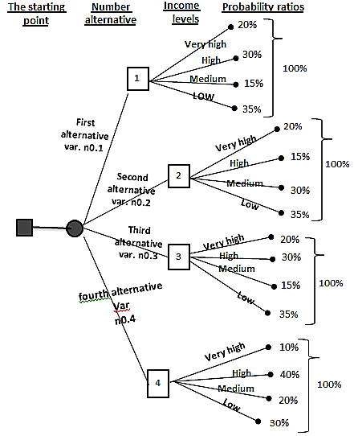
Figure (4) The tree of alternatives to the expected future strategies according to the expected probability ratios
For the purposes of this study, the choice was made on one of these alternatives, specifically variant 1 (Var.n0.1). In order to adopt this alternative and to show the benefits achieved, especially for income levels, it is necessary to use one of the methods of decision theory which is Bayesian theory.

  - Use Bayes theory to determine the best alternative of available strategies
This theory is one of the methods of decision theory Decision theory depends on the positions of potential decision-makers in the bank, and rely on the previous and subsequent calculations in the framework of specialized research studies. In other words, the application of this method requires a statement of the probability position of the levels of revenue verification, since this has already been provided for the bank sample study as in the previous table (2). Which shows that the bank has before it four potential positions relating to the acceptance of revenues that can be achieved according to varying levels as follows:
1. The very high level of revenue with probability of 20% (P1)
2. High level of revenue with probability of 30% (P2)
3. Average income level with a probability of 15% (P3)
4. The low level of revenue with probability of 35% (P4)
The management of the Gulf Bank as a business organization, it is going to increase revenues at the desire of shareholders to establish this bank. In order to achieve this, it is necessary to move towards the establishment of various investment projects. While the bank records show that the management of the bank is moving towards the establishment of projects according to different sizes as investment strategies as follows:

- Approval of a project for a large bank (multiple branches) in commercial malls (Strategy n0.1).
- The adoption of a project for a large bank in one central location (Strategy n0.2)
- Approving a medium sized bank project near one of the commercial sites (Strategy n0.3)
- Adopting a project for a small bank in a residential neighborhood (Strategy n0.4)
- Not to establish any project (Strategy n0.5)

This is illustrated by the management of Gulf Bank. It has two kinds of strategies:

1.Operational strategies
2. Investment strategies

The above strategies reflect investment projects that may be approved by the management of the Gulf Bank. In order to evaluate these new projects, it is necessary to indicate what is expected from revenues or losses according to a probability perspective, This explains:

Table (4): Probability levels of revenue when adopting investment strategies
35% Low income | 15%Average Income | 30% High Income | 20% Very highIncome | Alternatives Strategies  C Cases of nature  ases of nature
1000 | 1200 | 2000 | 500 | Strategy n0.1
400 | 500 | 200 | -300 | Strategy n0.2
-1500 | 400 | 100 | 1000 | Strategy n0.3
100 | 1000 | -500 | 200 | Strategy n0.4
0 | 0 | 0 | 0 | Strategy n0.5
Source: Records of the Bank's management by researchers.

On the basis of the above, the management of the bank needs to study later under the so-called feasibility study, in order to evaluate these alternatives of investment strategies. In examining the reality of the records related to these problems, it was found that the management of the bank adopted four types of studies, each related to being different in terms of optimism or pessimism or in other words to be encouraging or encouraging decisions to adopt one or all of the strategies contained in Table (4) above, these studies are:
1) A positive study (very encouraging)
2) Positive (encouraging)
3) neutral study (not encouraging or discouraging)
4) A negative study (not encouraging)

This study has been analyzed by the decision makers in the Research and Studies Department at the said bank, by adopting probability ratios based on the external and internal environment effects related to the various levels of probability of accepting revenues , Where this department has prepared Table (5) below:
Table (5): The nature of the studies presented and the levels of probability acceptance of revenues
Targeted nature situations
The nature of the studies presented to the bank administration |  |  |  | Revenue according to probability acceptance levels  Targeted studies
Negative (non-encouraging) | study neutral (neutral) | positive (study encouraging) | positive study (very encouraging)
20% | 20% | 35% | 25% | Achieving revenues at a very high level P1
10% | 40% | 30% | 20% | Achieving high level revenues P2
25% | 35% | 25% | 15% | Achieving revenues at an average level P3
30% | 40% | 10% | 20% | Achieving revenues at a weak level P4
Source: Department of Research and Studies in the management of the bank by the disposal of researchers.

In the light of the above, according to the Bayes theory, it is necessary to recalculate the expected monetary value (EMV), in accordance with the above calculations, with the adoption of the first alternative Var.n0.1 contained in the alternatives tree shown in Figure (4) previously, and the calculation is based on table (5).

Based on the above, a comprehensive study was prepared for all of the above. Under this study, the situation was evaluated in general and based on the table (5) of the percentages related to the four studies conducted (a very encouraging study, Encouraging, impartial study, non-encouraging study). The calculation of the common probabilities and subsequent probabilities as shown in Table (7) has been taken into account. It is clear from this table the process of evaluating alternatives to strategies in order to obtain probability probability ratios taking into account the results obtained under the above four studies

Table (6): EMV recalculated all the expected financial results of the five projects according to the probability percentages of the revenue recognition levels
The probability ratios adopted in the first alternative are Var.n0.1 |  |  |  |  | Strategies for projects
EMV | Low 35% | Medium 15% | high 30% | Very high 20%
1405 | $$1500*\frac{35}{100}=525$$ | $$1200*\frac{15}{100}=180$$ | $$2000*\frac{30}{100}=600$$ | $$500*\frac{20}{100}=100$$ | Strategy n0.1
215 | $$400*\frac{35}{100}=140$$ | $$500*\frac{15}{100}=75$$ | $$200*\frac{30}{100}=60$$ | $$-300*\frac{20}{100}=-60$$ | Strategy n0.2
-235 | $$-1500*\frac{35}{100}=-525$$ | $$400*\frac{15}{100}=60$$ | $$100*\frac{30}{100}=30$$ | $$1000*\frac{20}{100}=200$$ | Strategy n0.3
75 | $$100*\frac{35}{100}=35$$ | $$1000*\frac{15}{100}=150$$ | $$-500*\frac{30}{100}=-150$$ | $$200*\frac{20}{100}=40$$ | Strategy n0.4
0 | $$0*\frac{35}{100}=0$$ | $$0*\frac{15}{100}=0$$ | $$0*\frac{30}{100}=0$$ | $$0*\frac{20}{100}=0$$ | Strategy n0.5

From Table (7) above, it is clear that the evaluation of alternatives and strategies for these four studies reveals four groups of probability ratios, ie, from the above, we conclude that the database in the Research and Studies Department may provide the Bank with the following probability indicators:

First: if the result of the study and analysis of the database is positive (very encouraging), the possibilities are:
P1 = 0.25 Accept too high
P2 = 0.30 high acceptance
P3 = 0.10 Average Acceptance
P4 = 0.35 Poor acceptance
Second: If the result of the study and analysis of the database is positive (encouraging), the possibilities are:
P1 = 0.30 Very high acceptance
P2 = 0.40 high acceptance
P3 = 0.17 Average Acceptance
P4 = 0.13 Poor acceptance
Third: If the study and analysis result of the database is neutral, the possibilities are:
P1 = 0.12 acceptance is too high
P2 = 0.34 high acceptance
P3 = 0.14 Average Acceptance
P4 = 0.40 Poor acceptance

Table (7) Calculation of subsequent and joint probabilities under the four feasibility studies
Total | Subsequent possibilities | Total | Common possibilities | From Table (5) | Initial possibilities | Cases of nature | Nature of study
 | 0.05÷0.20=0.25 |  | 0.20×0.25=0.05 | 0.25 | 0.20 | Accepting a very high p1 | Positive study  (very encouraging)
 | 0.06÷0.20=0.30  1 |  | 0.30×0.20=0.06  0.20 | 0.20 | 0.30 | Accept high p2
 | 0.02÷0.20=0.10 |  | 0.15×0.15=0.02 | 0.15 | 0.15 | Accept the average p3
 | 0.07÷0.20=0.35 |  | 0.35×0.20=0.07 | 0.20 | 0.35 | Weak acceptance p4
 | 0.07÷0.23=0.30 |  | 0.20×0.35=0.07 | 0.35 | 0.20 | Accepting a very high p1 | Positive study (encouraging)
 | 0.09÷0.23=0.40  1 |  | 0.30×0.30=0.09  0.23 | 0.30 | 0.30 | Accept high p2
 | 0.04÷0.23=0.17 |  | 0.15×0.25=0.04 | 0.25 | 0.15 | Accept the average p3
 | 0.03÷0.23=0.13 |  | 0.35×0.10=0.03 | 0.10 | 0.35 | Weak acceptance p4
 | 0.04÷0.35=0.12 |  | 0.20×0.20=0.04 | 0.20 | 0.20 | Accepting a very high p1 | Neutral study
 | 0.12÷0.35=0.34  1 |  | 0.30×0.40=0.12  0.35 | 0.40 | 0.30 | Accept high p2
 | 0.05÷0.35=0.14 |  | 0.15×0.35=0.05 | 0.35 | 0.15 | Accept the average p3
 | 0.14÷0.35=0.40 |  | 0.35×0.40=0.14 | 0.40 | 0.35 | Weak acceptance p4
 | 0.04÷0.21=0.19 |  | 0.20×0.20=0.04 | 0.20 | 0.20 | Accepting a very high p1 | A negative study  not encouraging))
 | 0.03÷0.21=0.14  1 |  | 0.30×0.10=0.03  0.21 | 0.10 | 0.30 | Accept high p2
 | 0.04÷0.21=0.19 |  | 0.15×0.25=0.04 | 0.25 | 0.15 | Accept the average p3
 | 0.10÷0.21=0.48 |  | 0.35×0.30=0.10 | 0.30 | 0.35 | Weak acceptance p4

Fourth: if the result of the study and analysis of the database is negative (not encouraging), the possibilities are:
P1 = 0.19 Accept too high
P2 = 0.14 High acceptance
P3 = 0.19 Average Acceptance
P4 = 0.48 Poor acceptance

Based on these four totals, the expected EMV and each type of feasibility study are recalculated as follows:

First: If the feasibility study is positive (very encouraging), the expected financial value of EMV is calculated as Table (8).

Second: If the feasibility study is positive (encouraging): The expected financial value is calculated as Table (9).

Third: If the feasibility study is neutral calculated as Table (10).

Fourth: If the feasibility study is negative and not encouraging calculated as Table (11):

On the basis of the above analyzes, the Bank can pave the way for the decision-making process after the following calendar was issued:
First: Table (8) where the study is very positive and encouraging: From this table it is clear that Strategy N0.1 is the best because it achieved an expected monetary value (EMV) of (1195) monetary units. This is done in accordance with this strategy when a project for a large bank (in multiple branches) is adopted in commercial malls.

Second: Table (9): The study is positive and encouraging:
Where it also won the first strategy Strategy N0.1 as it achieved the highest revenue of (1504), and the strategy No. (3) the worst, because it achieved a loss.

Third: Table (10) The study is neutral: It shows from this table that the first strategy Strategy N0.1 achieved the highest revenue (1308) in terms of the previous strategy and the next was worse because it leads to loss.

Fourth: Table (11) The study was negative and not encouraging, and it appears from the table mentioned that the first strategy Strategy N0.1 is the best where it achieved (1083) monetary units as well as the third strategy was the worst and under which the adoption of the medium-sized bank near One of the commercial sites. It remains up to the decision maker to choose the appropriate strategy or
Table (8) Positive study (very encouraging)
nature situations
EMV | Low acceptance 35%  Alternatives strategies used | Medium acceptance 15% | High acceptance 30% | Very high acceptance 20%
1195 | $$1000×\frac{35}{100}$$ | $$1200×\frac{10}{100}$$ | $$2000×\frac{30}{100}$$ | $$500×\frac{25}{100}$$ | Strategy n0.1
175 | $$400×\frac{35}{100}$$ | $$500×\frac{10}{100}$$ | $$200×\frac{30}{100}$$ | $$-300×\frac{25}{100}$$ | Strategy n0.2
205 | $$-1500×\frac{35}{100}$$ | $$400×\frac{10}{100}$$ | $$100×\frac{30}{100}$$ | $$1000×\frac{25}{100}$$ | Strategy n0.3
10 | $$100×\frac{35}{100}$$ | $$1000×\frac{10}{100}$$ | $$-500×\frac{30}{100}$$ | $$200×\frac{25}{100}$$ | Strategy n0.4
000.0 | $$0×\frac{35}{100}$$ | $$0×\frac{10}{100}$$ | $$0×\frac{30}{100}$$ | $$0×\frac{25}{100}$$ | Strategy n0.5
project.
Alternatives strategies used
nature situations

- Conclusions and Recommendations
  - Conclusions
nature situations
1) that the management of the Gulf Bank, can evaluate the strategies available to them using the quantitative methods, especially adopted in the case of the environment of risk as well as the theory of Bayes theory.
Alternatives strategies used
2) The bank sample study, and by choosing the optimal strategies, it can maximize its revenue by choosing the best ones.
(3) The management of the bank can rationalize strategies and investment decisions through the use of studies and subsequent research in the framework of what is known as feasibility study.
(4) The management of the bank can not develop its work without attention to all subsequent possibilities and attachment to each of the investment projects in order to maximize revenues.
5) The management of Gulf Bank still needs to absorb all the external and internal environmental influences.

Table (9) Positive Studies (Encouraging)
EMV | Low acceptance13% | Medium acceptance 17% | High acceptance 40% | Very high acceptance 30%
1504 | $$1000×\frac{13}{100}$$ | $$1200×\frac{17}{100}$$ | $$2000×\frac{40}{100}$$ | $$500×\frac{30}{100}$$ | Strategy n0.1
215 | $$400×\frac{13}{100}$$ | $$500×\frac{17}{100}$$ | $$200×\frac{40}{100}$$ | $$-300×\frac{30}{100}$$ | Strategy n0.2
-117 | $$-1500×\frac{13}{100}$$ | $$400×\frac{17}{100}$$ | $$100×\frac{40}{100}$$ | $$1000×\frac{30}{100}$$ | Strategy n0.3
65 | $$100×\frac{13}{100}$$ | $$1000×\frac{17}{100}$$ | $$-500×\frac{40}{100}$$ | $$200×\frac{30}{100}$$ | Strategy n0.4
000.0 | $$0×\frac{13}{100}$$ | $$0×\frac{17}{100}$$ | $$0×\frac{40}{100}$$ | $$0×\frac{30}{100}$$ | Strategy n0.5

Table (10) Neutral Study
EMV | Low acceptance 40% | Medium acceptance 14% | High acceptance 34% | Very high acceptance 12%
1308 | $$1000×\frac{40}{100}$$ | $$1200×\frac{14}{100}$$ | $$2000×\frac{34}{100}$$ | $$500×\frac{12}{100}$$ | Strategy n0.1
-262 | $$400×\frac{40}{100}$$ | $$500×\frac{14}{100}$$ | $$200×\frac{34}{100}$$ | $$-300×\frac{12}{100}$$ | Strategy n0.2
-390 | $$-1500×\frac{40}{100}$$ | $$400×\frac{14}{100}$$ | $$100×\frac{34}{100}$$ | $$1000×\frac{12}{100}$$ | Strategy n0.3
494 | $$100×\frac{40}{100}$$ | $$1000×\frac{14}{100}$$ | $$-500×\frac{34}{100}$$ | $$200×\frac{12}{100}$$ | Strategy n0.4
000.0 | $$0×\frac{40}{100}$$ | $$0×\frac{14}{100}$$ | $$0×\frac{34}{100}$$ | $$0×\frac{12}{100}$$ | Strategy n0.5

Table (11) The study is negative (not encouraging)
EMV | Low acceptance 48% | Medium acceptance 19% | High acceptance 14% | Very high acceptance 19%
1083 | $$1000×\frac{48}{100}$$ | $$1200×\frac{19}{100}$$ | $$2000×\frac{14}{100}$$ | $$500×\frac{19}{100}$$ | Strategy n0.1
258 | $$400×\frac{48}{100}$$ | $$500×\frac{19}{100}$$ | $$200×\frac{14}{100}$$ | $$-300×\frac{19}{100}$$ | Strategy n0.2
-440 | $$-1500×\frac{48}{100}$$ | $$400×\frac{19}{100}$$ | $$100×\frac{14}{100}$$ | $$1000×\frac{19}{100}$$ | Strategy n0.3
206 | $$100×\frac{48}{100}$$ | $$1000×\frac{19}{100}$$ | $$-500×\frac{14}{100}$$ | $$200×\frac{19}{100}$$ | Strategy n0.4
000.0 | $$0×\frac{48}{100}$$ | $$0×\frac{19}{100}$$ | $$0×\frac{14}{100}$$ | $$0×\frac{19}{100}$$ | Strategy n0.5

5.2 Recommendations

1) The researcher recommends adopting the methods of decision theory, in particular quantitative methods EMV, EVPI, EOL and Bayesian theory in evaluating strategies before final adoption.
2) The bank must move towards maximizing its revenues in light of the fierce competition currently in the Iraqi market with the presence of nearly 50 private and government sector banks.
3) The need to go towards scientific research, and the management of the Gulf Bank to adopt feasibility studies before the start of the adoption of strategies and future projects.
4) The Bank's management should anticipate all future and future prospects and recalculate them in the light of both types of possibilities to create an acceptable probability expectation that will realize its future projects and objectives.
5) The management of the Gulf Bank should study and analyze all the external and internal environmental influences in the Iraqi market, in order to formulate sound and clear for future banking projects and this is within the quantitative approach away from the decisions of intuition and guesswork.
Alternatives strategies used
nature situations

REFERENCE
- L.LAPLN "Quntiteve Methods-For Business Decisions with eases" P.E. New york,(2002(
- Tgh.M.lT. Maghaddam "Decision Making under uncertain and Risk Situation" Tehran 2009.ZEINI, Dr. ABDULHUSSEIN 1990 the economic census, book, the second edition, DAR-ALIHIKMAH press. Baghdad. Iraq.
- Al - Fadhel, Moayad Abdul - Hussein, "Quantitative and qualitative methods and their role in supporting the decisions of the Organization" issued by Al - Warraq Publishing and Distribution, Jordan, Amman, 2008.
- Al-Bakri, Thamer Bar "Communications Marketing and Promotion" Dar Al-Hamed Publishing and Distribution - Jordan - Amman 2009.
- Al-Fadhel, Moayad Abdul-Hussein "The Quantitative Approach in Business Administration" Al-Warraq Publishing and Distribution Foundation- Jordan, Amman 2009.
- Najjar, Fayez "Administrative Information Systems" issued by Dar Al-Fikr Al-Jami` and Dar Al-Hamed Publishing and Distribution- Jordan Amman 2007.
- Smacka , Ali Mahmoud "Marketing Decision Support Systems and Promotional Mixing and Their Role in Rationalizing Consumer Behavior - A Comparative Study in Iraqi Banks", PhD Thesis Presented to the Board of the College of Administration and Economics, Karbala University, 2016.
- S. Makridakis, S.C. Wheelwright and R.J. Hyndman (1998) ,''Forecasting Methods and Applications'' ,Third Edition, John Wiley & Sons, Inc. Publication, New York, USA

