Effectiveness of ethanolic extracts for chamomile and Propolis against fungi (Rhizoctonai solani Kühn) causing root rot of broad bean (Vicia faba L.)
¹Hamed Abdzaid Al-khafaji ² Mohsen Abdulla Al-Musafir ³Hadi Abudul Jaleel Naas
^{1,2} Al- Mussaib Technical Institute ,Al-Furat Al-Awsat Technical University, 51009, Babylon province , Iraq.
³Al- Mussaib Technical College , Al-Furat Al-Awsat Technical University, 51009, Babylon province , Iraq.
Inm.ham69@atu.edu.iq
Inm.mos@atu.edu.iq
hadinass77@gmail.com

Abstract
The laboratory and field study was conducted to test the efficacy of ethanol extracts of the Chamomile plant and Propolis of a plant nature against the pathogenic fungus Rhizoctonai solani, which causes the root rot of the broad bean plant, as concentrations (0.00, 0.50, 1.00, 1.50, 3.00, 6.00)% were used in two experimental units. Both the ethanol extract of Chamomile plant and Propolis. The results of the laboratory experiment showed the effectiveness of ethanol extracts of Chamomile plant and Propolis in inhibiting the growth of pathogenic fungi R. solani and for all concentrations used, as the average of inhibition reached (7.91 and 5.78) cm for both chamomile extract and Propolis respectively. The results of the Efficiency test for the ethanol extracts of chamomile and Propolis showed the concentration efficiency (6%) in preventing the growth and spread of pathogenic fungi R. solnai in the PDA growth medium, noting that there were no significant differences with the concentration (3%).
As for the field experiment, the results showed the excelled of the ethanol extract of the Chamomile plant in preventing the growth and development of the pathogenic fungus R. solani through the positive results of the most important significant traits of the broad bean plant in the fresh pod's weight, the weight of one the fresh pod, the fresh root system weight and the 1000 seed weight , with a general average of (738.24, 37.54, 6.34, 1399.91 g) respectively, while the ethanol extract of Propolis had the least effective in preventing the growth and development of the pathogenic fungus R. solani of the mentioned specific traits at a general average amounted to (672.75, 30.95, 5.96, 1392.96 g) respectively.

Introductio
Broad bean (Faba vicia L)is one of the plants belonging to Fabaceae family , Spread out in many countries of the world where it is considered an important source of food for millions of the world's population and among the poor communities and those with limited income, especially, because its seeds contain a high percentage of protein ranging from 22-36%, that have An important effect in reducing animal protein deficiency in these societies as well as containing carbohydrates, calcium, iron, vitamin, vitamin 1, vitamin B2, in addition to improving the characteristics of agricultural soils due to their ability to stabilize atmospheric nitrogen by Leguminosarum Rhizobium bacterial nodes (Sharma ,2004).
Broad Bean plants Infection from many fungal and insect diseases with an economic impact on this important crop. Among these diseases is the Rot roots, which is caused by the fungus Rhizoctonia solani, Kuhn and is considered one of the most widespread diseases and causes great losses to the crop under appropriate environmental conditions. This fungus has a very wide range as it, in addition to causing root rot, causes the seedlings of many of its widely spread families (Hibbett , et al., 2007). The fungi live in the soil as an active Mycelium and can remain in the soil for a long time as well as forming stone bodies that are able to remain in the soil for a long time, That the use of chemical pesticides, systemic fungicides or antibiotics despite Its effectiveness indicates that it causes soil and environmental pollution as well as its high cost (Al-Adil, 2006). Therefore, recent studies have directed to the use of natural extracts that are effective in many fungal and insect diseases and because they are safe and environmentally friendly as well as easy to use and cheap in price. From this section, this research has been proposed using the following:

1. Chamomile
It is known scientifically as Matricaria chamomilla. The part used is the flowers and branches, where the flowers contain 1% of the essential oil, while the percentage in the branches is 20 - 35%. One of its most important compounds is the Azulin that is effective against infections. Its flowers also contain bitter materials. Flavonoids, polystyrene and nitrogenous materials contain proteins, including iron and lead, as well as fatty acids. They also contain 4.6 - 15% of shamazolin, flavonoids, bitter substances (Al-Khazraji, 2008).
2. Propolis
It is a sticky resin that Worker bees collect from tree bark, leaves and buds of some trees, such as palm trees, conifers, eucalyptus, and other aromatic and non-aromatic plants (Durrant, et al., 2004).
Honey bees workers remove Propolis gum in their upper jaws and secrete from them their jaw glands substances that help mix these materials from different types of active enzymes that are secreted from the bee head and chest. Many medical and therapeutic properties, old and new, as well as its use by bees to strengthen its woody cell and fix tires The embalming of insects to prevent their degradation and decomposition inside the cell and sterilize the hexagonal wax eyes of the bee larvae. This article also has the effect of preserving eggs and larvae against various types of viruses, bacteria and fungi in addition to the primary animals Anti-protozoa and against cancerous diseases Anti-tumor ( Marcucci, et al., 2001).
Materials and Methods
The experiment was conducted in the lath house at the Al-Musaib Technical Institute using the pots with a capacity of 5 kg for the agricultural season 2018-2019, the experiment was conducted according to the Randomized Complete Block Design (RCBD) and with three replicates per treatment, which included 6 treatments for each of the two experimental units when the extracts under study.
First: Prepare ethanol extracts:
1. Chamomile

Chamomile extract prepared by taking 500 g (flowers and stems) and put in a clean and sterile volumetric flask with a capacity of 1000 ml and then added to it 1000 ml of ethanol alcohol and left for one hour and then filtered by a clean cloth, and then filtered by(watman No 1) filter paper ، The solution was concentrated by a rotary evaporator device to obtain a dense extract and then repeated the process several times to obtain the required quantity and then put in clean and sterile dark glass bottles and put in the refrigerator until use, the concentrations were taken (0.00, 0.50, 1.00, 1.50, 3.00, 6.00) %.
2. Propolis
Prepare the bee gum by taking 50 g of raw material after cleaning it from impurities and soil, then cut into small pieces and put in a clean and sterile volumetric flask with a capacity of 500 ml, then add 500 ml of ethanol alcohol and concentrate the extract with a rotary evaporator under a temperature of 45 º C. The process was repeated several times. Times to obtain the required quantity, put the concentrated extract in clean, sterile, dark glass bottles and put in the refrigerator until use, the concentrations worked (0.00, 0.50, 1.50, 1.00, 3.00, 6.00)%.
Second: Creating experimental units:
A- Sand loamy soil was prepared, where it was well mixed and physical laboratory tests were conducted and then sterilized by heat.
B. 30 hooks with a capacity of 5 kg, with 15 bonds, were configured for each experimental unit.
C. Add 4.5 kg of soil/pot and add NPK fertilizer to it according to the recommended percentage.
D. The isolation of Rhizoctonia solani was prepared in the microbiology laboratory where a 1:10 suspension was carried. It was carried on a fungal vaccine on millet seeds and added to the soil at a rate of 0.5% w / w of millet-bearing fungus seeds (Dewan, 1989).
E. The soil of the pots was contaminated with the isolation of the Rhizoctonia solani and mixed with the soil well. After that the soil was moistened and left for several hours before planting.

Third: Fogging the seeds of the beans:

1. Broad Bean brought local seeds.
2. Use gum Arabic to load the ethanol extract of chamomile and Propolis to fogging the Broad Bean seeds.
3. cultivated 5 seeds / pot and Thinning after growing into one plant / pot.
4. The fogging seeds were cultivated and left with the fungus in the pot of the control treatment of both experimental units.
5. The soil was irrigated with water at every irrigation, and the soil retained its field capacity.
The results were calculated after the ripening of the soft pods in each plant.
6. The germination percentage was calculated according to the following formula:
Germination % = $\frac{Growing seeds}{Total seeds}$×100
Fourth: The biological efficacy test of ethanol extracts of Chamomile plant and Propolis in inhibition of R. solani pathogen.
The culture medium was prepared by PDA (Potato dextrose agar) according to the method (Emmons et al 1977) by dissolving 40 g dextrose, 10 g Peptone and 20 g agar in one liter of distilled water, then the antibiotic Chloramphenicol was added in an amount of 250 mg (Dewan, MM1989), and mixed The components were used by the magnetic shaker (Magnate stirer) for the purpose of homogenizing the culture medium and then sterilized using an Autoclave at 121 ° C and 15 bar pressure for 15 minutes. After sterilization, cool the medium at 45 ° C. Where 20 mL of the culture medium was poured into sterile plastic dishes for one-time use with a diameter of 9 cm and three replicates for each concentration. Both extracts Propolis and Chamomile with control treatment and left to harden the culture medium and then Spread 1 ml of each of the following concentrations (0.00, 0.50, 1.00, 1.50, 3.00, 6.00)% ,Then it was left for half an hour to dry and then pollinated by placing 5 mm of R. solani fungus in the center of the dish and incubated in the dark at a temperature of 30 º ° ± 2 for 5-7 days (Roys and Ries, 1978), the diameter of the inhibition area was measured by the ruler Taking two orthogonal measurements, the Abbott equation in (Shaban and Al-Mallah, 1993) was applied:

The average of Inhibition % = $\frac{A-B}{A}$ $×100$
Where as;
A: The average diameter of control treatment.
B: The average diameter of the biological preparation treatment.
Fifth: Statistic Analysis
The experiment was conducted according to the Randomized Complete Block Design (RCBD) and compared the results using the least significant difference (L.S.D)at a significant level 0.05% (Alrawi and Khalaf Allah, 2000), and the results were analyzed using the statistical program (NCSS, 2007).
Results and discussion
1.Results
Table (1) data showed the effectiveness of ethanol extract of Propolis in inhibiting the growth of R. Solani fungi that causes rot of leguminous roots through positive results of the qualitative traits of beans, where the germination ratios of treatment (D, C, B, E) increased with increasing concentration as it reached (80). 100, 100, and 100%, respectively, compared to the control treatment, in which the germination percentage was (26%). The results also showed an increase in the plant height when the treatment (E) with a higher concentration (6.00%) was amounted to 110.32 cm compared to the control treatment in which the plant height amounted to 7.56 cm. The same treatment also excelled the pod's weight per plant, the one pod weight, the fresh root system weight, and the 1000 seed weight where they reached (24.31, 984.06, 40.48, 7.38 and 1800.69) g, respectively. While there were no significant differences in the fresh root length of each of the treatments (E, D) at the two concentrations (3.00 and 6.00)% where the lengths (9.00 and 9.11) cm were respectively, Also, the same treatments and at the same two concentrations did not give any significant difference in the 1000 seed weight which gave (1800.69,1800.11) g, respectively. The results of the interaction between the treatments and the qualitative traits of the Broad bean showed the effectiveness of treatment (E) with a concentration of
(6.00)%. significant efficacy in the qualitative traits of the Broad bean on the rest of the treatments, where it gave a general average of (424.14) compared to the control treatment (A) with an overall rate of (4.22).

Table (1) The qualitative traits of the Broad Bean plant cultivated in soil contaminated with fungus Rhizoctonai solani and treatment with ethanol extract of propolis.
 |  | Qualitative traits of Broad Bean |  |  |  |  |  |  | Germination  Peracentage(%) | Concentration | Treatments
The average of concentr-  ations | 1000 seed weight  (g) |  | fresh root length  (cm) | fresh root system weight  (g) | Fresh pod weight  (g) | weight of fresh pods/  plant | The number of fresh pods (pod/pla-nt) | The plant length  (cm)
4.22 | 0.00 |  | 3.11 | 2.00 | 0.00 | 0.00 | 0.00 | 7.56 | 26 | 0.00 | A  ( Control)
205.74 | 968.22 |  | 5.22 | 5.41 | 22.07 | 352.45 | 15.97 | 70.82 | 80 | 0.50* | B
225.69 | 1002.85 |  | 6.19 | 5.00 | 24.04 | 468.72 | 19.97 | 73.11 | 100 | 1.00 | C
408.70 | 1800.11 |  | 9.00 | 6.10 | 37.20 | 860.78 | 23.81 | 98.95 | 100 | 3.00 | D
425.18 | 1800.69 |  | 9.11 | 7.33 | 40.48 | 841.11 | 24.31 | 110.32 | 100 | 6.00 | E
------ | 1392.96 |  | 7.38 | 5.96 | 30.95 | 672.75 | 21.02 | 88.30 | The average of qualitative traits
a.Concentration : 1.108 b.Interaction : 0.889 c.Qualitative traits : 0.984 |  |  |  |  |  |  |  |  | LSD: 0.05
* All data express three replicates

The results in Table (2) showed the effectiveness of the ethanol extract of chamomile plant in providing a root zone (Rizospher) free of pathogens, especially root rot disease caused by pathogenic fungus R. solani, where all research treatments (B, C and D) gave germination percentage with an effect High significance and increase in concentration reached (86.00, 93.00, 100, 100)%, respectively, while there were no significant differences in germination percentage for each of the treatments (D, E) at concentrations (3.00, 6.00)% where it reached (100)% for both treatments. Respectively. Compared to the treatment (A), in which the germination percentage reached (26), The results in Table (2) showed that the ethanol extract of the chamomile plant was positive in all the significant traits of the broad bean and for all research treatments (E, D, C, B) with concentrations (0.50, 1.00, 1.50, 3.00, 6.00) respectively, Where it gave a significant increase in the plant length amounted to (98.30, 110.11, 139.00, 145.72) cm, respectively, compared to the control treatment (A) with a concentration of (0.00)% where the plant length was (7.56) cm.The treatment (E) with a concentration of (6.00%) surpassed the rest of the treatments in the number of fresh pods/plant where it reached (38.00) pods / plant, compared to the control treatment (A) which did not give any yield in the pod's number
Table (2) the qualitative traits of the Broad Bean cultivated in soil contaminated with the fungus Rhizctonai
solani khun and treatment with ethanol extract of the chamomile plant.
 |  | Qualitative traits of Broad Bean |  |  |  |  |  |  | Germination  Peracentage(%) | Concentration | Treatments
The average of concentr-  ations | 1000 seed weight  (g) |  | fresh root length  (cm) | fresh root system weight  (g) | Fresh pod weight  (g) | weight of fresh pods/  plant | The number of fresh pods (pod/pla-nt) | Theplant length  (cm)
4.22 | 0.00 |  | 3.11 | 2.00 | 0.00 | 0.00 | 0.00 | 7.56 | 26 | 0.00 | A  ( Control)
231.23 | 962.83 |  | 7.11 | 5.77 | 30.71 | 501.00 | 20.00 | 98.30 | 86 | 0.50* | B
276.92 | 1009.42 |  | 7.48 | 5.98 | 32.85 | 750.08 | 22.54 | 110.11 | 93 | 1.00 | C
410.22 | 1806.07 |  | 11.00 | 6.50 | 41.31 | 885.78 | 36.97 | 139.00 | 100 | 3.00 | D
418.54 | 1821.33 |  | 13.30 | 7.11 | 45.27 | 984.06 | 38.00 | 145.72 | 100 | 6.00 | E
1341.13 | 1399.91 |  | 9.72 | 6.34 | 37.54 | 738.24 | 29.37 | 123.28 | The average of qualitative traits
a. .Concentration : 1.00 b.Interaction :0.800 c.Qualitative traits : 0.977 |  |  |  |  |  |  |  |  | LSD: 0.05
* All data express three replicates

The results in Table (2) also showed a significant difference in the weight gain of the significant traits of broad bean throughout all the treatments (B, C, D, E) and by increasing the concentration in the treatments as the fresh pods weigh per plant increased, the fresh pod's weight, the fresh root system weight, and the 1000 seed weight Where treatment (E) excelled all of these traits as it reached (38.00, 841.11, 45.27, 7.11 and 1821.33) g respectively, compared to the control treatment (A) where the above qualitative traits were completely absent (0.00, 0.00, 2.00, 0.00) g, respectively. The results also showed a significant increase in the fresh root length of each plant in all treatments, and lengths increased by increasing the concentration, where the concentration (6.00)% in treatment (E) gave the highest increase in the root length of (13.30) cm, compared with the control treatment (A) when The minimum length of the fresh root was (3.11) cm.

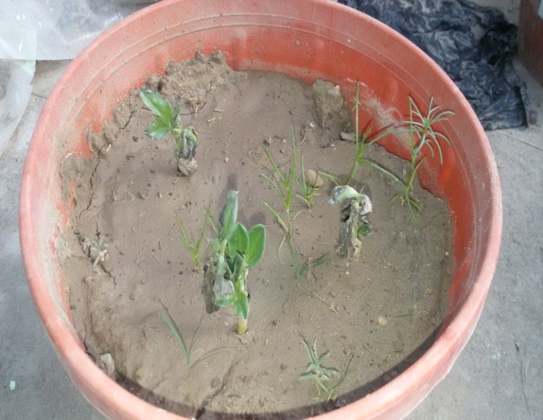
Picture (1) control treatment without dresing Broad Bean seeds in soil contaminated with the
pathogenic fungus R. solani and the appearance of wilting signs on the seedlings of broad bean plant.

The results in Table (3) in testing the effectiveness of ethanol extracts of chamomile and Propolis showed high efficiency in general in inhibiting the pathogenic fungi that caused the root rot of the broad bean, where the diameters of inhibition of the fungus ranged depending on the concentration of the extract used in the inhibition, where the ethanol extract was given to a plant Chamomile has the highest efficacy when concentrated (1.50%), Where the inhibition diameter reached (8.77) cm and without any significant differences with the two highest concentrations (3.00, 6.00)% where the inhibition diameter for the two mentioned concentrations was (8.77, 8 g 70)% respectively, compared to the control treatment where the inhibition diameter was (0.00), The results in Table (3) showed the presence of inhibitory activity of Propolis against the pathogenic fungi R. Solani in general, with no significant differences for the ethanol extract of Propolis for each of the concentrations (1.00, 1.50)%, where it gave an inhibition diameter of (6.11, 6.10) cm on respectively, there were no significant differences for the aforementioned extract of each of the two concentrations (3.00, 6.00)% in the inhibition of the pathogenic fungi where they were inhibition diameter (6.60, 6.66) cm respectively, compared to the control treatment (0.00)% where no inhibition of the fungus was 0.00 ) cm. The results of interaction showed that both extracts and concentrations excelled the concentration (3.00%) with an overall average inhibition diameter amounted to (7.71) cm on the one hand, and on the other hand, the ethanol extract of chamomile in the inhibition diameter average with a general average of (8.03) cm, compared with the ethanol extract of the Propolis, where the inhibition diameter reached a general average amounted to (5.99) cm.
Table (3): the biological efficacy of ethanol extract for Chamomile and Propolis against pathogenic fungus Rhizctonai solani laboratory..
Inhibition diameter of pathogen fungus Rhizctonai solani (cm ) |  |  |  |  |  |  | Extract
Concentations %
Average | 6.00 | 3.00 | 1.50 | 1.00 | 0.50 | 0.00 Control
8.03 | 8.70 | 8.77 | 8.77 | 7.77 | 6.11 | 0.00* | Chamomile
5.99 | 6.66 | 6.60 | 6.10 | 6.11 | 4.44 | 0.00 | Propolis
7.01 | 7.70 | 7.71 | 7.44 | 6.94 | 5.27 | 0.00 | Average
a.Extracts;1.00 b.Concentrations :3.53 c.Interaction : 2.22 |  |  |  |  |  |  | LSD:0.05
* All data express three replicates

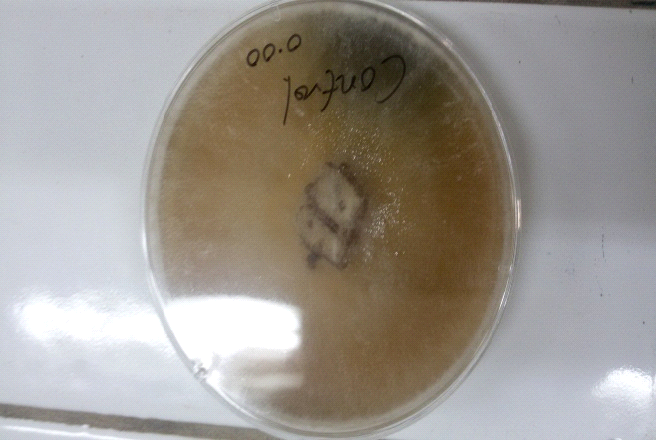
Picture (2) control treatment with a concentration of (0.00)% for R.solani and
developing fungi on the PDA culture medium.

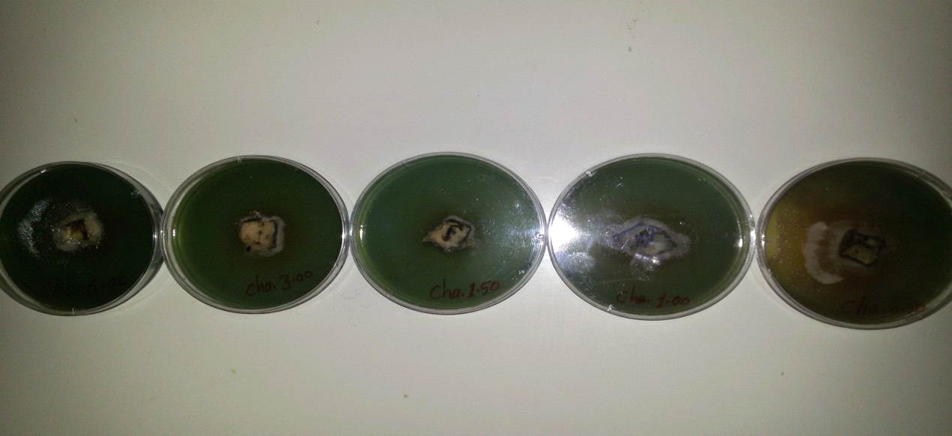
6.00 | 3.00 | 1.50 | 1.00 | 0.50
Concentration%
Picture (3) inhibition of pathogenic fungi R. solani using ethanol extract of chamomile plant on the
laboratory culture medium PDA.
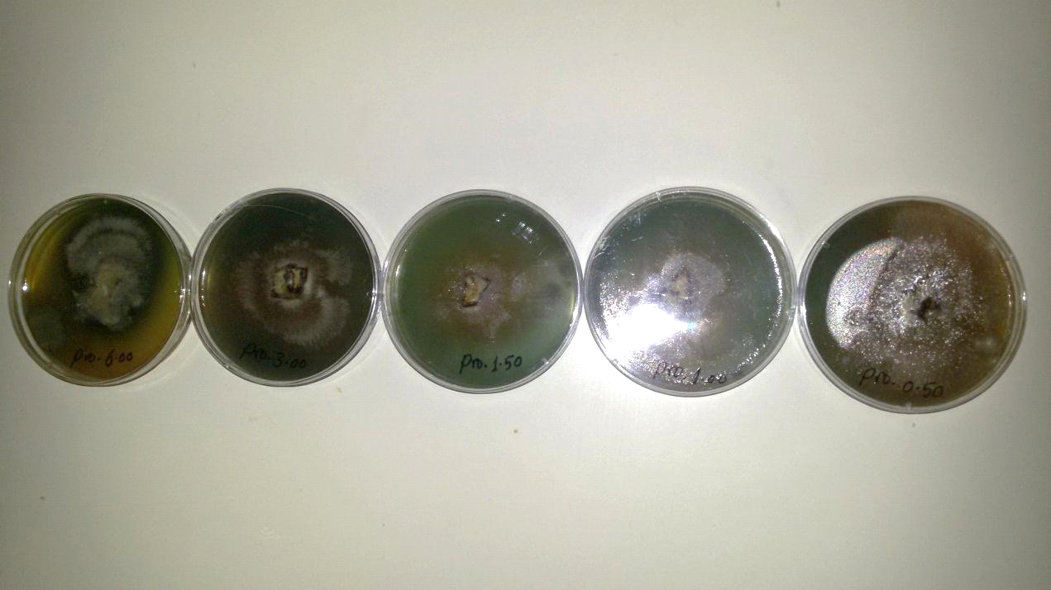
6.00 | 3.00 | 1.50 | 1.00 | 0.50
Concentration %
Image (4) Inhibition of pathogenic fungus R. solani using ethanol extract of Propolis on laboratory
culture medium PDA.

2.Discussion
The results of the study showed that plant extracts and extracts of a plant nature, such as Propolis, have an effective effect and according to the type of extract material, ethanol alcohol has the ability to extract and replace effective compounds in most parts of the plant used in influencing the microorganisms that are pathogenic to plants, animals, and humans alike, and to what these plant extracts contain. Effective materials and compounds, such as phosphates, volatile oils, alkanes, and others. This result agrees with (Al-Rajab, 2007) that chamomile plants are highly effective in inhibiting microorganisms such as fungi and pathogenic bacteria, including compounds, bitter substances, flavonoids, polystyrene, and nitrogenous materials containing important proteins, effective fatty acids, tannins, saponins, glycosides, and resins, despite the wide range of pathogenic effects of the fungus. R. solani damages most of the plant roots and their remaining in the soil, and this is consistent with what he mentioned (Hibbett et al ,2007). Propolis also had an important effect in inhibiting the pathogenic fungus R. solani, as it contains effective substances and compounds such as volatile oils, flavones, etc. These results agree with(Al-Fadali, 2007) as it contains volatile compounds by creating saturated and unsaturated fatty acids such as lemon, alkene, alkaline and compounds others, and that both the propolis samples extracted with ethanol have resulted in a clear inhibition either in the growth of the mycelium or in the germination of fungal spores. . and the possibility of using propolis where a natural material in fungal biomedical contamination of food and stored grains that do not have harmful side effects, and the effectiveness of plant extract compounds increases by increasing the concentration in the field and laboratory conditions, and that they are environmentally friendly compounds and have no harmful effect on manufacturers and workers in the field of biological control, Contrary to the use of harmful and polluting chemicals in the environment by remaining in the soil for many years, as well as their direct impact on workers and their transmission through the food chain.

Reference

Al-Adil, Khaled Mohammed (2006). Pesticides, basic concepts and their role in the agricultural and health fields. College of Agriculture, University of Baghdad, 442 pages.
Al-Fadali, Hussein Abdullah Muhammad, (2007). Antifungal activity of ethanol extract of propolis honey bees, Faculty of Agriculture, Damietta University, Egypt, p. 12.
Al-Khazraji, Ammar Salem. (2008), Encyclopedia of Alternative Medicine, Lexicon of Medical Herbs. Al-Hadi House for Printing and Publishing, Beirut - Lebanon, first edition, 976 pages.
Al-Rajab, Ashwaq Talib Hamid (2007). Effect of some Chamomile Anthemis noblis extracts on some human bacterial pathogens. College of Science, Anbar University. G.1.
Alrawi, Khashi Mahmoud and Abdul Aziz Khalaf Allah (2000), design and analysis of agricultural experiments. Second edition, Ministry of Higher Education and Scientific Research. House of Books for Printing and Publishing. Mosul - Iraq. 488 pages.
Dewan, M. M., & Sivasithamparam, K. (1989). Growth promotion of rotation crop species by a sterile fungus from wheat and effect of soil temperature and water potential on its suppression of take-all. Mycological Research, 93(2), 156-160.‏
Durrant,W.E.and X.Dong.(2004). Systemic acquired resistance .Annu Rev Phytopthol., 42:185-209.
Hibbett DS, Binder M, Bischoff JF, Blackwell M, Cannon PF, Eriksson OE (2007). A higher level phylogenetic classification of the fungi. Mycol. Res. 111 :509-547.
Jerry L.& Hintze,(2007).NCSS system, kaysville,Utah 84037-pp 2823.
Marcucci, M. C., Ferreres, F., Garcıa-Viguera, C., Bankova, V. S., De Castro, S. L., Dantas, A. P., ... Paulino, N. (2001). Phenolic compounds from Brazilian propolis with pharmacological activities. Journal of ethnopharmacology, 74(2), 105-112.‏

Shaban, Awad and Nizar Mustafa Al-Mallah, (1993) Pesticides, Dar Al-Kutub for Printing and Publishing, University of Mosul, page 520.
Sharma, B.D., H. Arora, R. Kumar, and V.K. Nayyar.2004. Relationships betweensoil characteristics and total and DTPA-extractable micronutrients in Inceptisols of Punjab. Commun. Soil Sci. Plant Anal. 35: 799 – 818.

